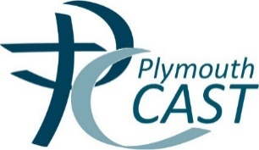

Staff Safeguarding Declaration
Dear Colleagues
By signing this form, you are confirming that you have read, understood and will abide by the Plymouth CAST Staff Code of Conduct (July 2019), the CAST Health and Safety Policy (July 2019) and Keeping Children Safe in Education (2019). Please sign this declaration by:
12 noon on Friday 13 September.
With thanks for all you do to keep our children safe and help them to flourish.
Raymond Friel, CEO

Employee Name | Employee Signature

Staff Safeguarding Declaration

Employee Name | Employee Signature

Staff Safeguarding Declaration

Employee Name | Employee Signature

