Primary Assessment Policy

Plymouth CAST believe that assessment should be at the heart of what we do for the pupils in our schools. This policy is designed to implement a consistent approach from all schools within the Trust to provide accurate and robust assessments on all pupils.
This rigorous approach to assessment will be used to ensure that all schools are clearly tracking the progress made by all pupils as well as identifying specific groups. It will in turn provide consistent data which will identify strengths and weaknesses across the Trust.
Aims
- To gather information about the performance of individual children, groups and cohorts in order to inform target setting and to monitor progress
- To provide information to inform the schools and the Trust’s strategic planning
- To gather information to inform teachers’ planning
- To allow children to be involved in their own learning
- To inform the Schools, Governing Body, Trust Directors and senior central staff of each school’s standards and achievement
- To ensure that the positive achievements of a child are recognised and the next steps are planned
- To ensure that barriers to learning can be identified quickly and appropriate intervention and support is given
- To systematically record the overall achievements of all children
- To ensure that the legal requirements for record-keeping, assessing and reporting are met
- To develop consistent approaches to assessment for all pupils in Plymouth CAST

How assessments are made
Plymouth CAST fully believe that the purpose of assessing pupils is to help improve progress and attainment for each individual pupil. To gather this information, teachers within the trust will use a range of both formative and summative assessments.
Formative Assessments
Teachers will use a variety of techniques such as observations, questioning and feedback to pupils to ascertain the pupils’ understanding. This Assessment for Learning will support teachers when discussing an individual pupil’s progress with SLT, parents and the pupils themselves.
Plymouth CAST place great value in the quality of feedback given to pupils. Each school must have their own marking and feedback policy, which has been ratified by their LGB. The underpinning philosophy is that feedback to pupils is personalised and tailored to challenge each individual in order for all pupils to make progress.
Feedback comes in many different forms from verbal feedback, marking comments, and ‘next steps’ in pupils’ books. It is important to us that all of these assessments help to build a picture of a pupil’s understanding and how/what to plan next in order to make progress.

Summative Assessments
Every primary school will test pupils for Reading and Maths in all year groups from Year 1 to Year 6. These tests will happen three times across the year. The data from these assessments must be uploaded to Target Tracker, no later than the data submission dates in Appendix 2.
(Once you receive your information pack of PIRA and PUMA you will able to analyse your own school data with the Rising Stars analysis tool, which has been found to be useful to conduct gap analysis of questions. This is not a trust requirement.)
The results of the summative assessments, once uploaded to Target Tracker, will be analysed and strengths and weaknesses identified across the Trust. Each assessment cycle, (See appendix 2) will result in the presentation of school level data, and Trust wide analysis, to the Rapid Improvement Group.(RIG - this group meets in advance of each Trust Board meeting, with a specific remit to address school improvement issues).
All schools will use Target Tracker to help track progress and attainment. It is paramount that Target Tracker is used appropriately and that it is a tool to inform planning and identify gaps in learning, see Appendix 1. Teachers MUST still plan from the National Curriculum.
Target Tracker is merely a software tool in which teachers collect evidence and populate statements. It then informs teachers where pupils are currently working at in each Year Group. Decisions about where a pupil is working will be teachers’ professional decision with Target Tracker to support with this. Target Tracker also provides Interim Framework statements which should be used in Y2 and Y6 progress meetings for a holistic view of the individual’s next steps and targeted teaching.
All teachers must submit data every half term into Target Tracker. Dates for these Data drops can also be found in Appendix 2.
Predictions
Each school will provide predictions three times a year (See Appendix 2). This will be a prediction on the percentage of pupils achieving:
- GLD
- Phonics
- Expected and exceeding standards in Reading, Writing and Maths at KS1
- Expected and exceeding standards in Reading, Writing, Maths and the combined measure at KS2
- Expected and exceeding Progress over key stage
- Progress
Progress from starting points
A key measure for any school is to identify the prior attainment group for each cohort of pupils, in order to identify whether high expectations are enabling pupils to continue to progress at the rate that they can.
Monitoring of Assessment Practice
School level
- Lesson observations, learning walks and book scrutiny to monitor the effectiveness of formative assessment and support moderation of judgements.
- Conduct pupil progress meeting for each class (See appendix 3)
- Three times a year schools must complete the ‘complete data’ proforma and subsequent analysis on assessment template. This to be submitted to the central school improvement team.
Trust Level
- Termly Assessment day to collate and analyse data with recommendations presented to RIG.
Reporting to parents
It is each school’s responsibility to report the progress of the pupils to parents. There should be a minimum of two opportunities to share pupil progress with parents during the year. Of course schools can do this more frequently if they choose.
Parents should be informed of any gaps their child/ren may have and suggestions of how they can help and support at home. Parents will receive a written report on their child’s academic achievements and know the band in which they are currently working in.
Importance of Disadvantaged pupils
The Trust recognises that the progress of disadvantaged pupils is of paramount importance and must form a significant part of any analysis, a part of pupil progress meetings and in information provided to the board.
For the further detail on Plymouth CAST’s approach to disadvantaged pupils, please see Plymouth CAST’s Pupil Premium policy.

Appendix 1 – Standard Operating Procedures for Target Tracker
Target Tracker Assessment
All schools within CAST use an electronic tracking system called Target Tracker (TT). This enables teachers and leaders to accurately assess and discuss pupil progress. It is imperative that all schools use TT in the same way by:
- Highlighting statements red when children have covered the objective. When then teacher feels the objective has been achieved and there is evidence to support that, the statement is turned blue. When a teacher feels that a child has mastered an objective they turn the statement gold.
Year 5 child has achieved Number and Place Value

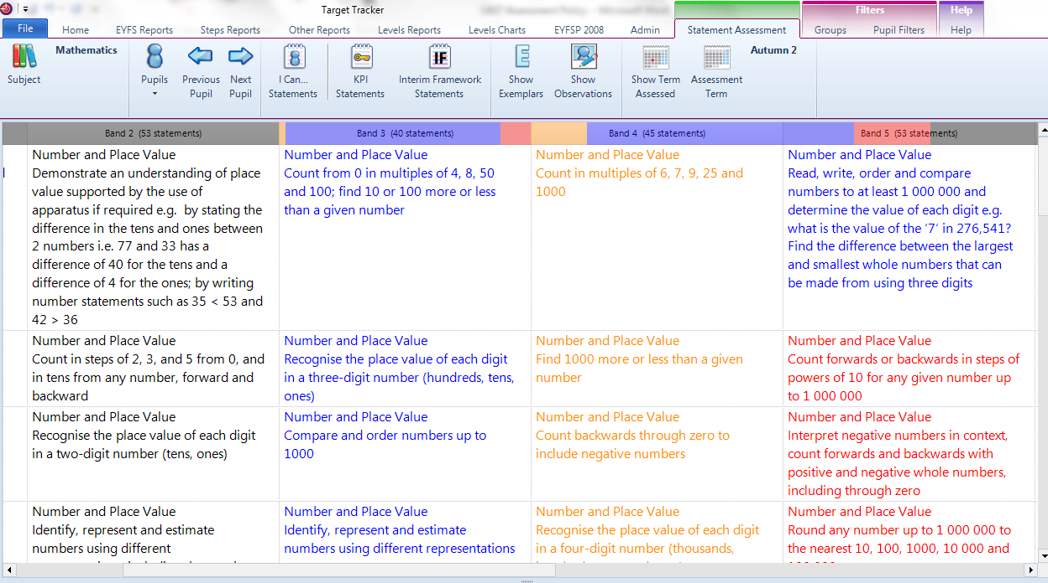

Year 5 child has evidence of mastery of some Band 4 objectives from the previous year.

Year 5 child has mastered these Band 4 statements

Year 5 child has been taught these objectives but the teacher doesn’t feel (or has evidence for) the child demonstrates a clear understanding yet

- Assessing (placing the dot) in the same place. As statements are assessed, the bar along the top will move in line with how the statements have been assessed. At each data drop, teachers will need to use the information from the bar to make an informed judgement. This judgment will be made by using the blue bar. The red bar shows that the child has been taught more of the Band 4 curriculum but has not demonstrated secure enough understanding so we don’t take this into account.
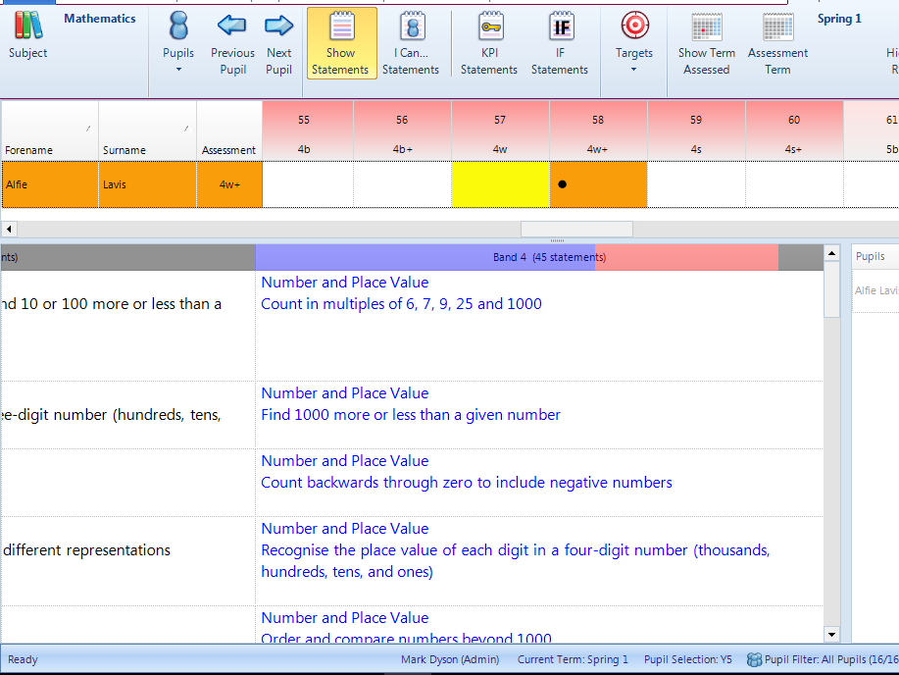
This child has been assessed at 4W+ because there are enough statements assessed as being achieved to show the child is working within this step.

- At no point should a child be assessed at a band if they haven’t achieved 75% of the statements from the previous Band. The picture below clearly shows that although the child has not achieved every statement at Band 4, they have achieved over 75% therefore has been assessed at 5B – at no point should a child be assessed out of their chronological band, (i.e. Y4 child should not be assessed at more than Band 4.)
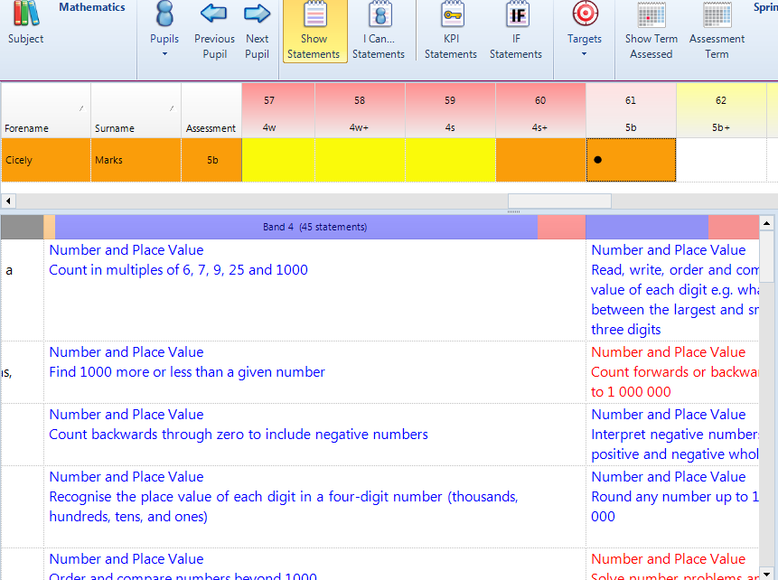
The bar here is mainly blue with a small amount of red. As the blue bar is over 75%, and there is sufficient amount of statements blue in the next band, the teacher has assessed this child at 5B.

- All schools within CAST will use W+ within any band to identify children who are on track to achieve expected standards at the end of the key stage. We will use S within any band to identify children who are securely on track to achieve expected standards at the end of the key stage. It is anticipated that children who are S+ are on track to achieve greater depth (high standard) at the end of key stage.

This class, at the time of the screen shot, have 8 children at W+ or above.

Assessing the Early Years
In the Early Years Foundation Stage, profile data is collected regularly against the 17 different areas of learning. This is recorded on Target Tracker and progress is tracked throughout the year. At the end of the year, children will receive a judgement against the Early Learning Goal, which forms their profile data. Children’s achievement of the Early Learning Goal will be recorded as Emerging, Expected or Exceeding. They will achieve their Good Level of Development (GLD) if they have achieved at least the expected level in the early learning goals in the prime areas of learning (personal, social and emotional development; physical development; and communication and language) and the early learning goals in the specific areas of mathematics and literacy.

We now ask that all schools use Development Matters as an assessment framework in 2017-18. A working party has been formed to identify a CAST wide EYFS assessment framework for the beginning of 2018-19, and schools will be updated and consulted on this process throughout the next academic year.

EYFS data is used to:
Inform parents about their child’s development against the Early Learning Goals (ELGs) and the characteristics of their learning.
Help Year 1 teachers to plan lessons and support to meet the needs of all pupils.

Administration of Target Tracker
Information on pupils e.g. attendance, PP eligibility, new pupils etc. must be updated at least half termly in line with the dates for the data drop above.
GLD, KS1 and KS2 data must be uploaded at least annually before the end of the summer term.
Appendix 2 – Assessment Cycle
Every school is required to update their data on TT on a half-termly basis. The information from each data drop will be inputted onto the Progress and Attainment Overview form and submitted to the Area Advisor. The first half of each term will be used for submission of predictions.
There are three assessment cycles throughout the year. Each school should administer the PIRA/PUMA tests at a point that suits their curriculum delivery, mark the tests and upload the data no later than the deadlines below. The dates for submission are as follows:
Cycle 1: Submission of predictions
Deadline for data: Friday 20th October 2017
Trust analysis day: Wednesday 1st November 2017
Cycle 2: Submission of summative assessment
Deadline for data: Wednesday 13th December 2017
Trust Analysis Day: Monday 8th January 2018
Rapid Improvement Group Wednesday 31st January 2018
Cycle 3: Submission of predictions
Deadline for data: Friday 9th February 2018
Trust analysis day Wednesday 21st February 2018
Cycle 4: Submission of summative assessment
Deadline for data: Wednesday 28th March 2018
Trust Analysis Day: Wednesday 18th April 2018
Rapid Improvement Group Wednesday 16th May 2018
Cycle 5: Submission of predictions
Deadline for data: 25th May 2018
Trust analysis day: Wednesday 6th June 2018
Cycle 6: Submission of summative assessment
Deadline for data: Wednesday 11th July 2018
Trust Analysis Day: Monday 16th July 2018
Rapid Improvement Group Wednesday 10th October 2018

Appendix 3 - Pupil Progress Meetings
Not every bit of Pupil Progress can be measured or identified using Target Tracker. In Plymouth CAST, we provide many learning opportunities for a wide range of children who make progress that isn’t academic, such as social and emotional. This progress is just as important, because longer term it will allow these pupils to make the academic progress. For this reason the class teacher meets with relevant members of the Senior Leadership Team once per half term.
The progress of individuals and specific groups of pupils is discussed in relation to assessment data that teachers have prepared. As a result of these meetings, targets may be revised and intervention groups planned. Trends across cohorts, different groups (see below), key stages and subject areas are collated and actioned as necessary.
The way progress meetings are conducted, along with the paper work to go with them and the personnel involved is all conducted at the individual schools’ discretion.
Tracking of groups
All pupils are tracked throughout the year and are discussed at Pupil Progress meetings, as are particular focus groups:
- Boys
- Girls
- Pupil Premium
- Persistent Absentees
- Middle Attainers
- Lower Attainers
- Special Education Needs and Disabilities
- English as an Additional Language
- Academically More Able
- Looked After Children
- White British
- Service Children
- Summer Born

Appendix 4 – Identification of Groups of Pupils
Identification of AMA at KS1:
To identify a child as AMA at KS1, a child needs to be assessed as Exceeding in Reading, Writing & Number in the Early Years. Achieving in only one or two of the areas will not be classified as AMA. However these children will still be expected to reach greater depth in that particular subject at the end of KS1.
Starting points for KS1 are tracked subject by subject, from ELG, (Reading, Writing and Number), for example a child achieving Expected in Number should be achieving Expected in Maths at the end of KS1.
Every class teacher is expected to know the starting points of the children in their class.
- For EYFS this will be the baseline assessment on Development Matters
- In KS1 this will be the end of EYFS data
- In KS2 this will be Prior attainment group generated from KS1 data
Identification of AMA at KS2:
To identify a child as AMA at KS2, a child needs to be assessed as Exceeding in Reading, Writing & Number in the Early Years OR to be in Prior Attainment Group of 18 or above at KS1. The formula to identify the Prior Attainment Group is to add the APS score for a pupil’s Reading, Writing and (Maths X2) and divide this by 4.
This is fine for pupils who are due to exit primary school in 2017, 2018 or 2019 as they were assessed at KS1 using ‘levels’. To identify if a pupil is AMA for pupils due to exit primary school in 2020 or thereafter, until we have clearer guidance from the Government, it will be any pupils who were Greater Depth in the KS1 tests in any of the following combinations:
- Reading and Maths
- Writing and Maths
At the end of KS2, to be counted as ‘achieving at a higher standard’, pupils must have a ‘high scaled score’ of 110 or more in reading and maths, and have been teacher assessed in writing as 'working at a greater depth’ within the expected standard.

Appendix 5 – Assessment Calendar
 | Sep-2017 |  |  |  |  | Oct-2017 |  |  |  |  | Nov-2017
Monday | 28 | 4 | 11 | 18 | 25 | 2 | 9 | 16 | 23 | 30 |  | 6 | 13 | 20 | 27
Tuesday | 29 | 5 | 12 | 19 | 26 | 3 | 10 | 17 | 24 | 31 |  | 7 | 14 | 21 | 28
Wednesday | 30 | 6 | 13 | 20 | 27 | 4 | 11 | 18 | 25 |  | 1 | 8 | 15 | 22 | 29
Thursday | 31 | 7 | 14 | 21 | 28 | 5 | 12 | 19 | 26 |  | 2 | 9 | 16 | 23 | 30
Friday | 1 | 8 | 15 | 22 | 29 | 6 | 13 | 20 | 27 |  | 3 | 10 | 17 | 24
Saturday | 2 | 9 | 16 | 23 | 30 | 7 | 14 | 21 | 28 |  | 4 | 11 | 18 | 25
Sunday | 3 | 10 | 17 | 24 | 1 | 8 | 15 | 22 | 29 |  | 5 | 12 | 19 | 26
 | Dec-2017 |  |  |  |  | Jan-2018 |  |  |  |  | Feb-2018
Monday |  | 4 | 11 | 18 | 25 | 1 | 8 | 15 | 22 | 29 |  | 5 | 12 | 19 | 26
Tuesday |  | 5 | 12 | 19 | 26 | 2 | 9 | 16 | 23 | 30 |  | 6 | 13 | 20 | 27
Wednesday |  | 6 | 13 | 20 | 27 | 3 | 10 | 17 | 24 | 31 |  | 7 | 14 | 21 | 28
Thursday |  | 7 | 14 | 21 | 28 | 4 | 11 | 18 | 25 |  | 1 | 8 | 15 | 22
Friday | 1 | 8 | 15 | 22 | 29 | 5 | 12 | 19 | 26 |  | 2 | 9 | 16 | 23
Saturday | 2 | 9 | 16 | 23 | 30 | 6 | 13 | 20 | 27 |  | 3 | 10 | 17 | 24
Sunday | 3 | 10 | 17 | 24 | 31 | 7 | 14 | 21 | 28 |  | 4 | 11 | 18 | 25
 | Mar-2018 |  |  |  |  | Apr-2018 |  |  |  |  | May-2018
Monday |  | 5 | 12 | 19 | 26 | 2 | 9 | 16 | 23 | 30 |  | 7 | 14 | 21 | 28
Tuesday |  | 6 | 13 | 20 | 27 | 3 | 10 | 17 | 24 |  | 1 | 8 | 15 | 22 | 29
Wednesday |  | 7 | 14 | 21 | 28 | 4 | 11 | 18 | 25 |  | 2 | 9 | 16 | 23 | 30
Thursday | 1 | 8 | 15 | 22 | 29 | 5 | 12 | 19 | 26 |  | 3 | 10 | 17 | 24 | 31
Friday | 2 | 9 | 16 | 23 | 30 | 6 | 13 | 20 | 27 |  | 4 | 11 | 18 | 25
Saturday | 3 | 10 | 17 | 24 | 31 | 7 | 14 | 21 | 28 |  | 5 | 12 | 19 | 26
Sunday | 4 | 11 | 18 | 25 | 1 | 8 | 15 | 22 | 29 |  | 6 | 13 | 20 | 27
 | Jun-2018 |  |  |  |  | Jul-2018 |  |  |  |  | Aug-2018
Monday |  | 4 | 11 | 18 | 25 | 2 | 9 | 16 | 23 | 30 |  | 6 | 13 | 20 | 27
Tuesday |  | 5 | 12 | 19 | 26 | 3 | 10 | 17 | 24 | 31 |  | 7 | 14 | 21 | 28
Wednesday |  | 6 | 13 | 20 | 27 | 4 | 11 | 18 | 25 |  | 1 | 8 | 15 | 22 | 29
Thursday |  | 7 | 14 | 21 | 28 | 5 | 12 | 19 | 26 |  | 2 | 9 | 16 | 23 | 30
Friday | 1 | 8 | 15 | 22 | 29 | 6 | 13 | 20 | 27 |  | 3 | 10 | 17 | 24 | 31
Saturday | 2 | 9 | 16 | 23 | 30 | 7 | 14 | 21 | 28 |  | 4 | 11 | 18 | 25
Sunday | 3 | 10 | 17 | 24 | 1 | 8 | 15 | 22 | 29 |  | 5 | 12 | 19 | 26
 |  |  |  |  |  |  |  |  |  |  |  | 13
key: | Deadline for data |  |  |  |  | Bank Holidays |  |  |  |  | Weekends
 | Trust analysis day |  |  |  |  | Rapid Improvement group

