Plymouth CAST non-exempt charity status

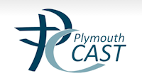

‘Plymouth CAST is a limited company (limited company number 08438686) with no issued share capital trading as a non-exempt charity and subject to all statements of recommended practice under a master funding agreement with the Secretary of State for Education’.

