Risk Management Strategy

(To be read in conjunction with Risk Register)

Introduction

The Risk Management Strategy aims to ensure that PLYMOUTH CAST complies with risk management best practice as adopted by academies. It forms the start point for Corporate Governance with the requirements of the Turnbull guidance and sets out the current processes and responsibilities for risk management in PLYMOUTH CAST.

1.1. The Turnbull guidelines for Corporate Governance were published in 1999, updated in 2005 and can be summarised as:

1.1.1 The Board acknowledges responsibility for the system of internal control

1.1.2 An ongoing process is in place for identifying, evaluating and managing all significant risks

1.1.3 An annual process is in place for reviewing the effectiveness of the system of internal control

1.1.4 There is a system in place to deal with internal control aspects of any significant issues disclosed in the annual report and accounts

1.2. In assessing what constitutes a sound system of internal control regards risk management, the Turnbull report states that consideration should be given to:

1.2.1 The nature and extent of the risks facing the organisation

1.2.2 The extent and categories of risk which it regards as acceptable

1.2.3 The likelihood of the risks concerned materialising

1.2.4 The organisation’s ability to reduce the incidence and impact of the risks that do materialise
1.3. Risk Management best practice for public organisations is encapsulated in the following documents, which have been adopted by several academies:

1.3.1 The Risk Management Standard published jointly by the major risk management organisations in the UK – The Institute of Risk Management (IRM); The Association of Insurance and Risk Managers (AIRMIC); and ALARM, The National Forum for Risk Management in the Public Sector. Available at the following link:

https://www.theirm.org/media/886059/ARMS_2002_IRM.pdf

1.3.2 HM Treasury’s “Management of Risk – Principles and Concepts” (“The Orange Book”) that provides guidance on developing a strategic framework for the organisational consideration of risk. Available at the following link:

https://www.gov.uk/government/uploads/system/uploads/attachment_data/file/220647/orange_book.pdf

Risk Management Objectives

2.1 The objectives for managing risk across the Academies are:

2.1.1 To comply with risk management best practice;

2.1.2 To ensure risks facing the Academies are identified and appropriately documented;

2.1.3 To provide assurance to the Board that risks are being adequately controlled, or identify areas for improvement;

2.1.4 To ensure action is taken appropriately in relation to accepting, mitigating, avoiding and transferring risks.

Risk Management Strategy

3.1 This strategy aims to:

3.1.1 Outline the roles and responsibilities for risk management.

3.1.2 Identify risk management processes to ensure that all risks are identified, controlled and monitored

3.1.3 Ensure appropriate levels of awareness throughout PLYMOUTH CAST

Roles and responsibilities

4.1 The PLYMOUTH CAST board has overall responsibility for risk management. The Chief Operating Officer has lead responsibility for risk management processes and PLYMOUTH CAST wide Risk Register. This responsibility includes:

4.1.1 Monitoring the performance of risk management processes

4.1.2 Ensuring that appropriate controls are in place to manage identified risks

4.1.3 Preparation of periodic reports to the Board and Diocese.

The Risk Register and Risk Management Plan will be formally reviewed each term by the Board.

Identification of risks

5.1 The Risk Management Standard states that risk identification should be approached in a methodical way to ensure that all significant activities have been identified and all the risks flowing from these activities have been defined.

5.2 PLYMOUTH CASTs approach to risk management is linked to strategic aims and objectives. These have been set and agreed with the Board and encompass 5 key aims:

5.2.1 Control risk to create capacity for sustainable and managed growth

5.2.2 Engender a culture of acute awareness of financial risks throughout the trust

5.2.3 Create clear lines of sight of accountability

5.2.4 Ensure clarity with all use of public funds

5.2.5 Provide efficient central support for the Trust

5.3 The structure and organisation of PLYMOUTH CAST’s risk register follows the above structure to ensure that all significant objectives and activities have been identified and the risks associated with each area have been identified. Through the register, accountabilities and the use of public funds can be both identified and protected

Evaluation of risks

6.1 The Risk Management Standard states that risks should be evaluated against agreed criteria to make decisions about the significance of risks to the organisation.

6.2 PLYMOUTH CAST will use a 5x5 matrix to assess impact and probability as high, medium or low, as illustrated in the diagram below:

 |  |  | Likelihood
 |  |  | Lowest |  | Low |  | Medium |  | High |  | Highest
 |  |  | 1 |  | 2 |  | 3 |  | 4 |  | 5
Impact | Lowest | 1 | 1 |  | 2 |  | 3 |  | 4 |  | 5
 | Low | 2 | 2 |  |  |  |  |  | 8
 |  |  |  |  | 4 |  | 6 |  |  |  | 10
 | Medium | 3 | 3 |  | 6 |  | 9 |  | 12 |  | 15
 | High | 4 | 4 |  | 8 |  | 12 |  | 16 |  | 20
 | Highest | 5 | 5 |  | 10 |  | 15 |  | 20 |  | 25

The descriptors for high, medium and low impact and probability can be expanded as follows:

Impact of risk occurring

Impact | Description
Highest | The financial impact will be in excess of £50,000
 | Has a significant impact on PLYMOUTH CAST’s strategy or on teaching and learning
 | Has significant stakeholder concern
High | The financial impact will be between £25,000 and £50,000
 | Has a moderate impact on strategy or on teaching and learning
 | High stakeholder concern
Medium | The financial impact will be between £5,000 and £25,000
 | Has no more than a moderate impact on teaching and learning
 | Moderate stakeholder concern
Low | The financial impact is likely to be below £5,000
 | Has a low impact on strategy or on teaching and learning
 | Low stakeholder concern
Lowest | The financial impact is likely to be below £1,000
 | Has no impact on teaching and learning
 | No stakeholder concern/financial department to monitor

Probability of risk occurring
Probability | Description | Indicator
Highest | Likely to occur within 12 months | Potential for repetition
 | More than 50% chance of occurrence | Has occurred before
High | Likely to occur within a 2 year period | Potential of it occurring more than once
 | Less than 50% chance it will occur in next 12 months | Has occurred in last 2 years recently
Medium | Likely to occur within a 3 years | Some history of occurrence
 | Less than 25% chance within 12 months
Low | Unlikely to occur within 4 years | Unlikely to occur more than once
 | Less than 10% chance within 12 months | Has occurred but not in last 4 years
Lowest | Not likely to occur within 4 years | Has not occurred

Risk appetite

7.1 The term risk appetite describes PLYMOUTH CAST’s readiness to accept risks and those risks it would seek to reduce. PLYMOUTH CAST’s risk threshold is the boundary delineated by the red shaded area (represented by scores of 15 and above) in the risk matrix in paragraph 6.2. Above this threshold, PLYMOUTH CAST will actively seek to manage risks and will prioritise time and resources to reducing, avoiding or mitigating these risks.

Addressing risks

8.1 When responding to risks, PLYMOUTH CAST will seek to ensure that it is anticipated and managed early so risk does not develop into an issue where the potential threat materialises. The main tool for doing so is projected monthly cash flow.

8.2 PLYMOUTH CAST will adopt one of the 4 risk responses outlined below:

8.2.1 Avoid. Counter measures are put in place that will either stop a problem or threat occurring or prevent it from having an impact on the business.

8.2.2 Transfer. The risk is transferred to a third party, for example through an insurance policy.

8.2.3 Treat. The response actions either reduce the likelihood of a risk developing, or limit the impact on PLYMOUTH CAST to acceptable levels.

8.2.4 Tolerate. Accept the possibility that the event might occur, for example because the cost of the counter measures will outweigh the possible downside, or the Board believes there is only a remote probability of the event occurring.

Risk Reporting and Communication

8.3 The aim of reporting risk is to provide assurance to the Board, Senior Management and Internal Auditors that PLYMOUTH CAST is effectively managing its risks and has a robust system of internal controls.

Risk register

8.4 The reporting mechanism will be PLYMOUTH CAST’s Risk Register and Management plan. This will highlight the key risks facing PLYMOUTH CAST, as well as a breakdown for each key strategic aim. The Risk Management Plan will be monitored by main Board on an annual basis and through termly reports prepared by the COO.

8.5 Any significant changes in risk impact or probability, or the occurrence of an event which raises the profile of a risk will be recorded on the risk register. Any new or increased risks identified in Board or LGB meetings, or raised by a member of staff will be evaluated and, if appropriate, recorded in the Risk Register. The board will be presented risks in a logarithmic scale according to the diagram below in order to assure visibility of complete risk profiles. For example Risk A would be escalated under a linear scale because it scores 20 but neither risk B or C would normally be escalated as they score only 5 and 8 respectively. Using a logarithmic scale assures the board they see both all risk themes that score high for either probability and/or impact.

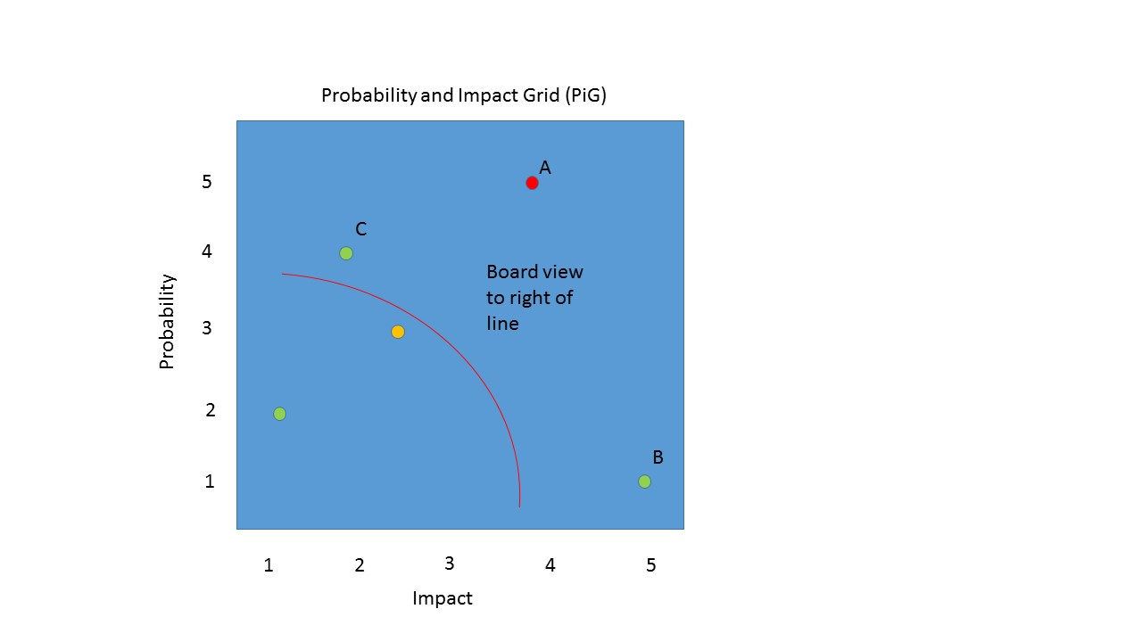

Communicating Risks

8.6 The Board will monitor the risk management plan each term. The COO will ensure that any perceived new or increased risks or significant failure of risk management control measures are considered by the Board along with a summary of actions taken.

8.7 The COO will endeavour to raise awareness that risk management is a part of PLYMOUTH CAST’s culture and seek to ensure that:

8.7.1 Individual members of staff are aware of their accountability for individual risks

8.7.2 Individuals report promptly to senior management any perceived new risks or failure of existing control measures.

Annual risk review and assessment

8.8 The internal audit reviews will aim to provide an annual assessment of the effectiveness of PLYMOUTH CAST’s management of risk. The COO will prepare an annual review of the risk management plan for the Board. This will enable the Board to review:

8.8.1 The significant risks facing PLYMOUTH CAST

8.8.2 The effectiveness of the risk management processes

8.8.3 That PLYMOUTH CAST has published a risk management policy covering risk management philosophy and responsibilities

Categories of Risk

9.1 The risk categories defined by the Treasury are set out below for reference:

9.1.1 External Risks

Risks arising from the external environment, not wholly within the organisation’s control, but where action can be taken to mitigate the risk

Political. Political constraints such as change of government

Economic. Interest rates, exchange rates, inflation

Socio Cultural Demographic. Change affecting demand for services or change of stakeholder expectations

Technological. Obsolescence of current systems; Procurement and best use of technology to achieve objectives

Legal / Regulatory. Laws and regulations which impose requirements (e.g. health & safety and employment legislation)

Environmental. The need for buildings to comply with changing standards (e.g. energy efficiency) equipment to comply with changing standards

9.1.2 Strategic/Operational Risks

Risk relating to delivery of current activities, building capacity and capability

Operations capacity and capability to achieve objectives; procedures employed

Service/Project Delivery failure to deliver the agreed service

Resources

Financial - availability and allocation of funding; poor budget management

Physical - security against loss, damage and theft of physical assets, and fraud including identification of areas which can be insured

Human - availability, retention, skills and capacity of staff

Information - adequacy of information for decision making; security of information against loss, damage, theft and fraud

Relationships - threats to relationships with delivery partners; customer satisfaction; accountability (particularly to Parliament)

Such relationships include ICT Support Contract (CSE), Utilities Suppliers, providers of maintenance contracts for facilities, including fire and intruder alarms etc.

Reputation - confidence and trust which stakeholders have in the organisation

Governance - propriety and regularity; compliance with relevant requirements; ethical considerations

Scanning - failure to identify threats and opportunities

Resilience - capacity of accommodation, systems and ICT to withstand adverse impacts and crises; contingency planning and disaster recovery (e.g. fire, flood, failure of power supply, failure of transport systems)

9.1.3 Change Risk

Created by decisions to pursue new endeavours beyond current capability

Public Sector Targets - new funding regime/formulae being applied to GAG funding

Change Programmes - programmes for organisational or cultural change threaten current capacity to deliver as well as providing opportunity to enhance capacity, for example the RSC requests the Trust to absorb several academies at once

New Projects - making optimal decisions/prioritising between new activities that are competing for resources (example for a MAT would be capacity to manage new conversions), for example allocation capital grant monies

9.1.4 Risk Themes

Risks will be categorised by ‘Theme’ so that the Trust can assess risk across business function and activity and determine appropriate balance. The themes are:

Health and Safety
Safeguarding
OFSTED Inspections
RSC Scrutiny
Section 48 Performance
Catholic Life
ICT
Physical Security
Cyber Security
External Influences
Political
Ethical/Reputational
Keeping Finances in order
Financial
MAT Managed
Insurance
Tax
Pensions
Acquisitions & disposals
Pay and Allowances
Information Management
Data Protection
Infrastructure and FM

