GRANT FUNDING OPPORTUNITIES

for pupils, staff,
schools and CAST
(updated)
December 2017

- Grants for young people
(b) Music for All [5]
http://www.musicforall.org.uk/apply-for-funding/
Individual grant application – grants for musical instruments/lessons. Deadlines: 1st Nov for Jan 2018, 1st Feb for April 2018, 1st July for September 2018

- PLCC (Plymouth Ladies Charity Club) [4]
https://plcc.org.uk/
Plymouth Ladies Charity Club is a recently launched charity, created to provide grants of up to £500 for children and young adults up to age of 25 in the PL postcode area. We welcome applications from children, their parents or carers in need of financial assistance, be it to achieve a long held ambition or to overcome a short term problem. (All schools in Plymouth plus Bodmin and Camborne).

(C)Awards for Young Musicians [13]
https://www.a-y-m.org.uk/
Grants for talented young instrumentalists in UK

(d) Heritage Lottery Fund – Young Roots [6]
https://www.hlf.org.uk/looking-funding/our-grant-programmes/young-roots

The scheme aims to involve 11-25 year-olds (up to 25 for those with special needs) in finding out about their heritage, developing skills, building confidence and promoting community involvement. Young Roots projects stem directly from young peoples’ interests and ideas, harnessing their creativity and energy and helping them work with others in their local community. Suitable for schools if in addition to core curriculum time and provision

- Grants for staff
- Education Support Partnership [14]
https://www.educationsupportpartnership.org.uk/helping-you/training-development-fund
- Training and Development fund, in partnership with the CSIS Charity Fund, specifically to assist:
- staff in education with the cost of education-related training
- former education staff to re-enter the education sector or to transition to a new career”

(b) Goldsmiths [16]
https://www.thegoldsmiths.co.uk/charity/education/grants-teachers/
- Grants for Teachers
Goal: to provide teachers and head teachers with an opportunity to take time out from the classroom in order to undertake an original project of their choice, in the UK or abroad, aimed at enhancing their personal and professional development. A grant, of up to £3,000, covers the cost of travel, accommodation, materials, etc. In addition the Company will pay a maximum of £2,000 supply cover to your school.

(c)Winston Churchill Memorial Trust [18,19,20]
http://www.wcmt.org.uk/categories/education
http://www.wcmt.org.uk/fellows/stories/education-fellows-story-collection
Grants for individuals who want to go to abroad to learn about an area of good practice in another culture – eg catholic education in another country, reaching disadvantaged kids, maths, English. Science, outdoor education, etc.

(d) The Leverhulme Trust [17]
https://www.leverhulme.ac.uk/funding/grant-funding
- research grants for individuals, (mainly academics).

- Grants for Schools and Trusts
(a)The Foyle Schools Library Scheme [25]
http://www.foylefoundation.org.uk/index.php?pageID=11
Foyle School Library Scheme – Grants of £3,000 - £7,000 available for schools to refurbish their libraries with books. [Priory received £4,000 from the Foyle Foundation).

(b) The Big Lottery Fund: Awards for All [26]
From the Big Lottery Fund, gives grants to projects that aim to build stronger, healthier and more active communities. You can apply for a grant worth between £300 and £10,000 to cover a range of costs including building and refurbishment, equipment hire and purchase and volunteer expenses. Applications are welcome all year round. - www.awardsforall.org.uk

(c ) EMI Music Sound Foundation [27]
The EMI Music Sound Foundation supports music education projects and activities in schools. You can apply for a grant worth up to £2,000 to purchase musical instruments and training courses for music teachers. There are two application deadlines a year. - www.musicsoundfoundation.com The Foundation has helped over two thousand schools, individual students and teachers improve their access to music through the purchase or upgrade of musical instruments and equipment. The Foundation provides grants up to a total of £2,000 towards the purchase of musical instruments and/or equipment for individuals who are in full time education and Schools who require the equipment to fund music education. We also fund courses and training opportunities for music teachers who work within schools.

(d) Ernest Cook Trust [28]
Educational Grants Ernest Cook Trust gives grants worth up to £4,000 for projects that educate young people about the environment, countryside and the arts. A wide range of projects are considered including: arts clubs and events, specialist teachers in dance, drama and music, artists in residence, musical instruments and equipment, gardening projects, outdoor learning, library books, installation of whiteboards and projectors and forest schools. Applications are welcome any time. - www.ernestcooktrust.org.uk/grants

(f) BBC Children in Need [new]
http://www.bbc.co.uk/programmes/articles/wWhd5lqf4RZ3xhL63G9Xmc/small-grants-what-you-need-to-know
Purpose: Grants awarded to projects working with children under 18 years old experiencing disadvantage through:
- Illness, distress, abuse or neglect, any kind of disability
- Behavioural or psychological difficulties
- Living in poverty or situations of deprivation
Who can apply? Schools, registered charities, churches, community interest groups
Funding: The Small Grants Programme funds up to £10,000 for projects of up to 3 years. The Main Grants Programme makes grants of over £10,000 for projects of up to 3 years.

(e ) Premier League & The FA Facilities Fund [29]
Grants of up to £500,000 are available to schools to develop or improve football facilities for community benefit. This includes changing rooms, grass or artificial pitches and multi-use games areas. Applications are welcome any time. - www.footballfoundation.org.uk/funding-schemes/premier-league-the-fa-facilities-fund/ Minimum award is £10,000. A small grants fund exists for any applications which require a lesser amount of money.

(g) Ragdoll Foundation Open Grants Scheme [new]
http://www.ragdollfoundation.org.uk/portfolio/grant-giving
Purpose: scheme supports organisations working with children and young people using the arts and creative media. Can apply for both one-off short term projects and for projects lasting up to 3 years. Preference given to projects which have a deep commitment to listening to children and allow the perceptions and feelings of children themselves to be better understood.
Who can apply: not for profit organisations. Interested in applications that involve children during their early years, but appropriate projects for older children will also be considered. Applications are considered on a rolling basis.
Funding: Most grants in region of £5,000 - £30,000 and cover between 25% and 80% of total costs.

(h) Wooden Spoon [new]
https://www.woodenspoon.org.uk/apply-for-funds
Purpose: Rugby charity that supports mentally physically disadvantaged children. Funding available through capital grants programme for: buildings and extensions; equipment & activity aids; sensory rooms and gardens; playgrounds and sports areas; transport and soft playrooms.
Who can apply: Schools and not for profit organisations
Funding: no minimum or maximum, but unlikely to be less than £5000
Deadline: Applications can be made at any time Applicants should contact their regional volunteer group.

(i) The Kids Fund Programme [new]
https://www.field-studies-council.org/about/fsc-kids-fund.aspx
Purpose: The Field Studies Council (FSC) operates a network of residential and day centres to provide environmental outreach education and training. The Kids Fund aims to bring environmental understanding to young people by attending a course at an FSC location and to help disadvantaged young people attend a course who may otherwise be excluded do to health, mobility, deprivation or financial.
Who can apply: School groups can apply if they are aiming to provide benefits which are additional to the statutory school curriculum or clearly show added value, depth and breadth to the taught curriculum.
Funding: Up to 80% of the course fee for groups of disadvantaged young people. This includes all equipment, tuition and waterproof hire costs. Food and accommodation included for residential courses. One free staff’/adult place is provided for every 12 young people: additional adults pay 20% plus VAT.
Deadline: 1 March, 1 June and 1 November each year.

(k) Education Endowment Foundation [new]
https://www.
Purpose: EEF exists to fund the development and evaluation of cost-effective and scalable projects that seek to improve the educational attainment of children and young people from disadvantaged backgrounds. Applications are now open for projects that aim to improve attainment and related outcomes for 3-18 year olds.
- Maths at KS2/3 – approaches to improving teaching within these stages, as well as approaches to supporting pupils make a successful transition
- Character/Life skills – project that aim to develop a set of attitudes, skills and behaviours that are thought to underpin success in school and work, e.g. self-control, resilience, social skills and motivation.
- Science programmes across both primary and secondary schools, particularly those looking to improve whole class teaching through CPD.
Who can apply: Mainstream primary and secondary schools.
Funding: up to £50,000 Deadline:

(j) Andy Fanshawe Memorial Trust [new]
https://www.andyfanshawe.org
Purpose: The Trust funds projects that give disadvantaged young people the chance to develop an existing interest in the great outdoors. Outdoor activities mean walking, climbing, cycling, kayaking, sailing, horse-riding and residential courses at daycentres.
Who can apply: Schools and youth groups.
Funding: not stated
Deadline: applications can be made at any time.

(l) The Institute for Mathematics [30]
https://ima.org.uk/support/grants/
Grants for secondary schools

(o) Garfield Weston Foundation [9]
https://garfieldweston.org/
Supportive of faith grants, Schools and charities can apply - aim of grant is to support organisations that gave effective solutions to helping those most in need, preference given to organisations that can show they are addressing a need and that their work is high quality. Major Grants (£100,000) and Regular Grants (up to £99,000) available.

- British Science Week [33]
https://www.britishscienceweek.org/about-us/grants/
Grant applications open in September 2017 for schools to run activities in British Science Week. [9th to 18th March 2018].
Kick Start Grants
This scheme offers grants for schools in challenging circumstances to organise their own events as part of British Science Week. There are two options available:
- Kick Start Grant: A grant of up to £300 for your school to run an activity
- Kick Start More grant: A grant of up to £700 for your school to host a science event or activity involves your students and the local community.
(m) Royal Society of Chemistry [37]
http://www.rsc.org/Membership/Networking/InterestGroups/BMCS/education-support-group/chemistry-clubs.asp
Grants of up to £1000 are available in 2 categories. Chemistry Clubs, and Chemistry equipment.
Enhanced Equipment, Chemistry Clubs
(n) London Mathematical Society [31,32]
https://www.lms.ac.uk/grants-prizes
Grants to ‘promote and extend mathematical knowledge’. One grant is for Maths teacher CPD. The other grant is to purchase equipment to enhance the teaching of Maths.

(p) The Lefevre Trust [10]
https://www.britishcouncil.org/schoolpartnerships-france-lefevre-trust
Grants for UK – France school visits
(r) Children and the Arts [11]
https://www.childrenandarts.org.uk/Pages/Category/arts-for-schools-category

START, a 3 year programme partnering schools in high need areas of the UK with their local arts venue, QUESTS, taking children on a year's cultural journey, exploring angles of a single art form, e.g. Falmouth Art Gallery, Cornwall

(q) British Science Week [36]
https://www.biochemistry.org/Grants/ScientificOutreachGrants.aspx
Supports scientific outreach activities that communicate the excitement of molecular bioscience to young people and the community Applications are invited for sums up to £1000 to assist with the direct costs associated with an event and expenses incurred (e.g. transport and/or teacher cover).

(s) Youth Music – Open Programme [12]
www.youthmusic.org.uk

Early Years – advancing the learning and development of all children in their early years (0-5) by aiming to ensure universal access to high quality music making in England -Challenging Circumstances – improving the life chances of children and young people in the most challenging circumstances by supporting them to achieve their full potential through engagement and progression in music making • Encouraging Talent and Potential – realising the musical talent and potential of children and young people by ensuring opportunity for all to develop their talent regardless of background or chosen genre • Workforce Development – enabling the highest quality music making by developing a diverse, highly skilled and inspirational workforce
Grants of between £5,000 and £30,000

(t) Royal Society of Chemistry [37]
http://www.rsc.org/Membership/Networking/InterestGroups/BMCS/education-support-group/
(a) Enhanced Equipment £100 - 500 (b) Chemistry Clubs (up to £1000) c) Partnership of 3 - supporting activities that bring together at least 3 different partners for chemistry outreach activities (up to £1000)
(u) The Royal Society – Partnership Grants [34]
https://royalsociety.org/grants-schemes-awards/grants/partnership-grants/
Partnership Grants of up to £3000 are available to schools to enable students, aged 5 – 18, to carry out science, technology, engineering or mathematics (STEM) projects.
(t) IOP Institute of Physics – School Grants scheme [35]
http://www.iop.org/about/grants/school/page_38824.html

Set up a science club, invite a working physicist or engineer, attend careers event

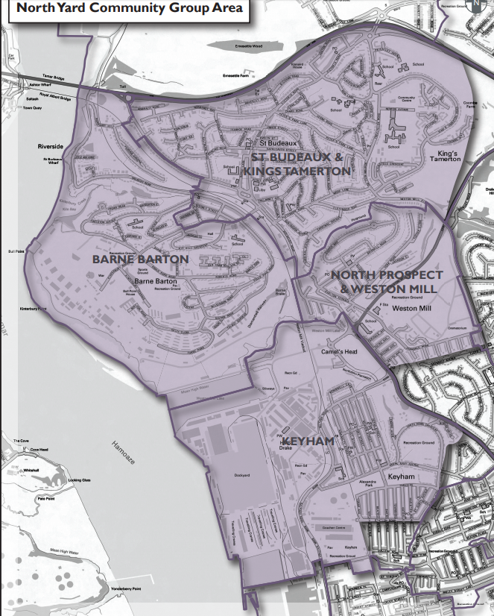
(v) North Yard Community Trust
http://northyardcommunitytrust.org.uk/grants.html
Anyone in Plymouth can apply; however, the project must benefit the communities of Barne Barton, Kings Tamerton, St Budeaux, Keyham and parts of Weston Mill (see map below) – Keyham Barton, St Paul’s, others.

